|  |  |
| --- | --- |
|  | **MATHEMATICS SPECIALIST 3 & 4**  **SEMESTER 1 2019**  **TEST 2**  **Calculator Free** |

Reading Time: 2 minutes Time Allowed: 21 minutes

Total Marks: 21

**Question 1 (2 marks)**

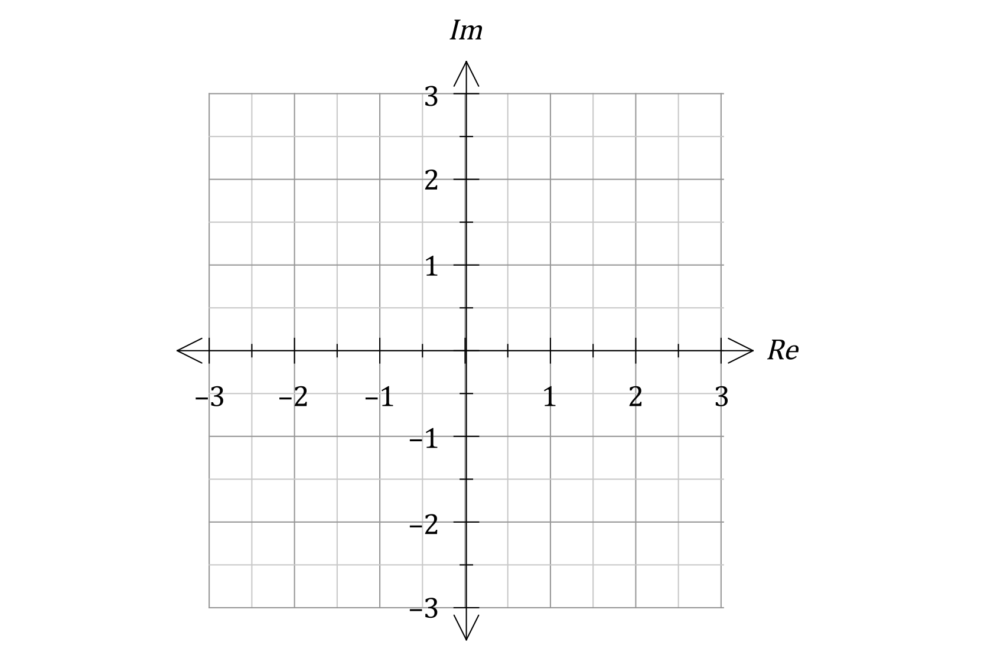Sketch the set of points z, in the complex plane, that satisfy the equation $\left|z-3i\right|= \left|z-3\right|$

|  |
| --- |
|  |

**Question 2 (4 marks)**

Evaluate (1 + i)7 + (1 – i)7 using de Moivre’s rule.

**Question 3 (9 marks)**

1. Let $z=a+bi$ be any complex number. (3 marks)

Obtain an equation relating $a, b$ given that Re $\left(\frac{z+i}{\overline{z}}\right)$ =0.

1. Let $z=rcisθ$ be any complex number. Obtain an expression for:
2. $\frac{-2i}{\overline{z}}$ (3 marks)
3. $arg⁡(z+r)$ (3 marks)

**Question 4 (6 marks)**

1. Solve the equation $z^{3}-8=0$ giving solutions in polar form $rcisθ$. (3 marks)

It can be shown that $P\left(z\right)=z^{5}+z^{4}+3z^{3}-8z^{2}-8z-24$ can be written in the form

$P\left(z\right)=\left(z^{3}-8\right)Q(z)$.

(b) Determine $Q(z)$. (1 mark)

(c) Hence solve the equation $z^{5}+z^{4}+3z^{3}-8z^{2}-8z-24=0$ giving all solutions in Cartesian form $a+bi$. (2 marks)

|  |  |
| --- | --- |
|  | **MATHEMATICS SPECIALIST 3 & 4**  **SEMESTER 1 2019**  **TEST 2**  **Calculator Assumed** |

Reading Time: 2 minutes Time Allowed: 35 minutes

Total Marks: 31

Question 5 (6 marks)

Two complex numbers are $u=\sqrt{3}+i$ and $v=3\operatorname{cis}\left(-\begin{matrix}π \\ \overline{ 4 }\end{matrix}\right)$.

(a) Determine the argument of $uv$. (2 marks)

(b) Simplify $|v×\overline{v}×u^{-1}|$. (2 marks)

(c) Determine $z$ in polar form if $5zu=v^{2}$. (2 marks)

Question 6 (8 marks)

(a) Let $r\operatorname{cis}{θ}$ be a point in the complex plane. Determine, in terms of $r$ and $θ$, the polar form of this point after it is rotated by $\frac{π}{4}$ about the origin and then reflected in the real axis.

(2 marks)

(b) Let $f(w)=-i\overline{w}+1+i$.

(i) Complete the following table. (3 marks)

|  |  |  |  |
| --- | --- | --- | --- |
| $$w$$ | $$1+2i$$ | $$-3+i$$ | $$-1-4i$$ |
| $$f(w)$$ |  |  |  |

(ii) Sketch each point, $w$, and join it with a dotted line to its image, $f(w)$, on the diagram below. (1 mark)

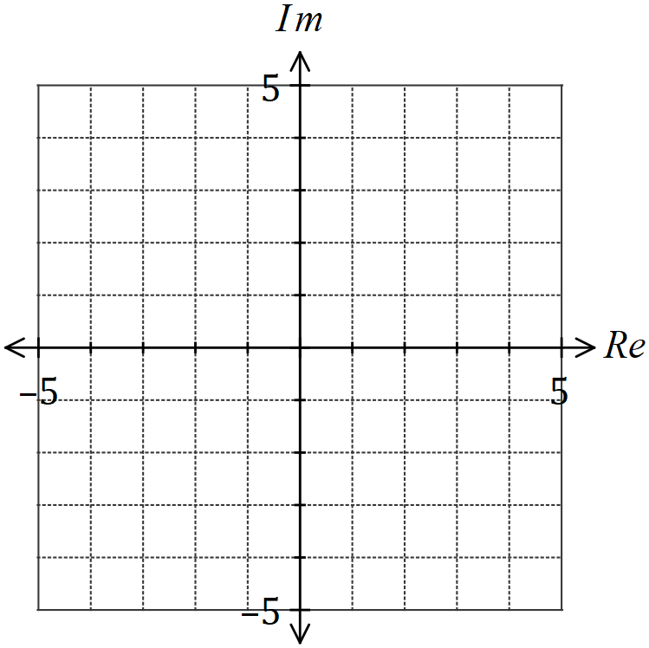

(iii) Describe the geometric transformation that $f\left(w\right)$ represents. (2 marks)

**Question 7 (8 marks)**

A sketch of the locus of a complex number $z$ is shown below. Write equations or inequalities in terms of $z$ (without using $x=$ Re $\left(z\right)$ or $y=$ Im $\left(z\right)$) for each of the following:

1. (3 marks)

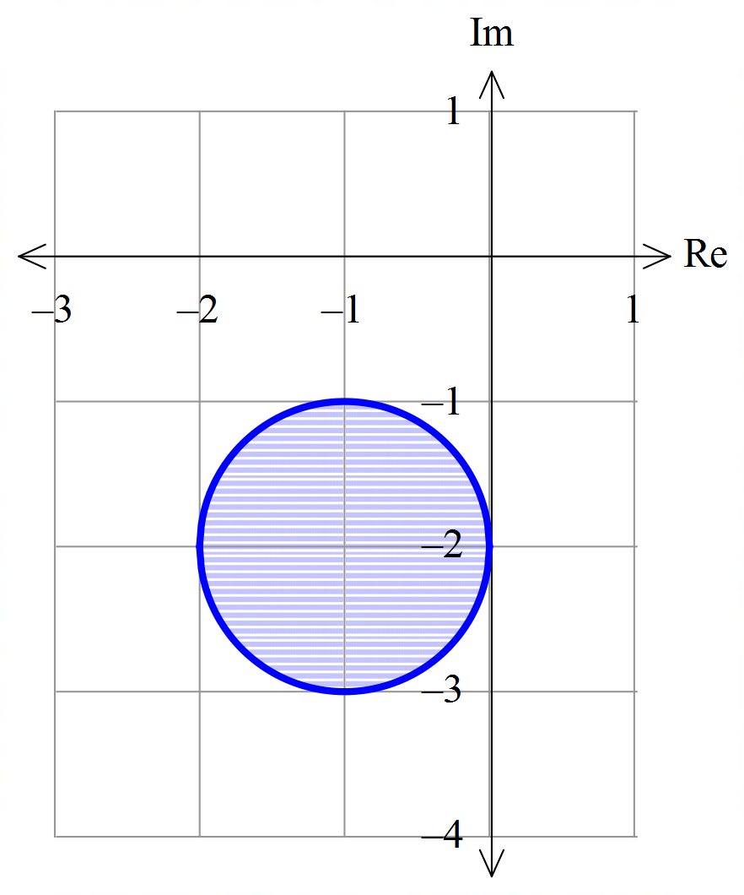

1. (2 marks)

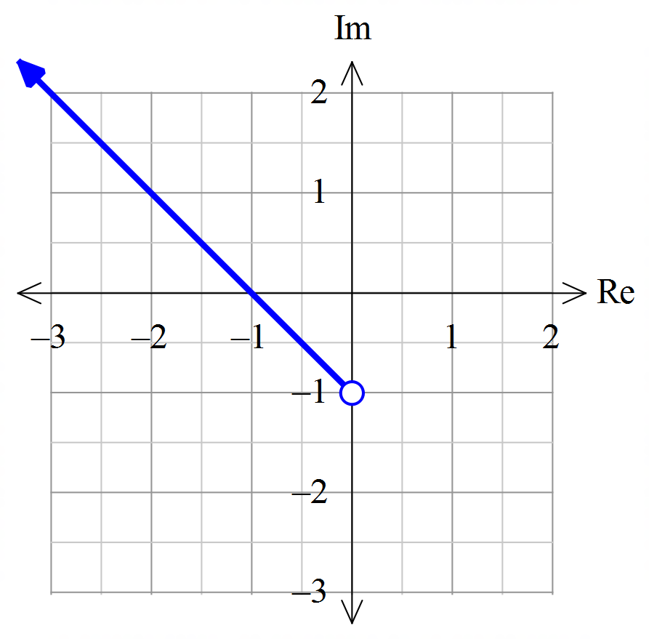

The sketch in (a) is repeated below, with only the circle indicated.

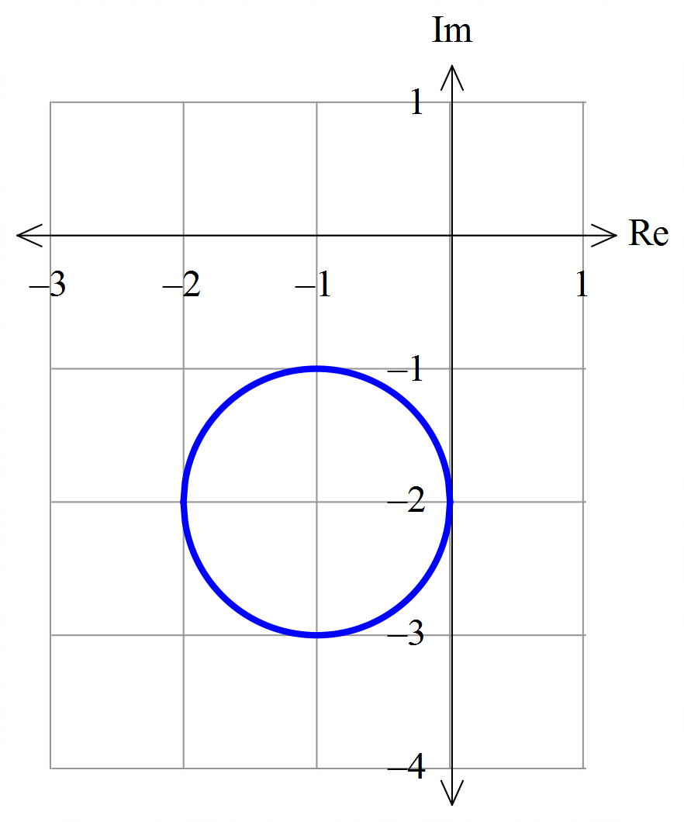

1. From the locus from part(a), determine the minimum value for $arg⁡(z)$ correct to 0.01, where

$0≤\arg\left(z\right)≤2π$. (3 marks)

**Question 8 (9 marks)**

1. Use De Moivre’s theorem to establish the identity

 . (4 marks)

(b) Determine the maximum and minimum values of



on the interval and the values of $x$ at these extremes.

(Hint: Let $x=\cos{θ}$ and use the identity in part (a).) (5 marks)